How to get your SSID for the Bot (For this example I will use Chrome screenshots, however it works exactly the same on edge)

1. Login to pocket options on your browser (chrome or edge)
2. Navigate to Demo or Real account which ever you’d like to use it on
3. Press CTRL + SHIFT + I on your keyboard to bring up the inspection tab
   1. 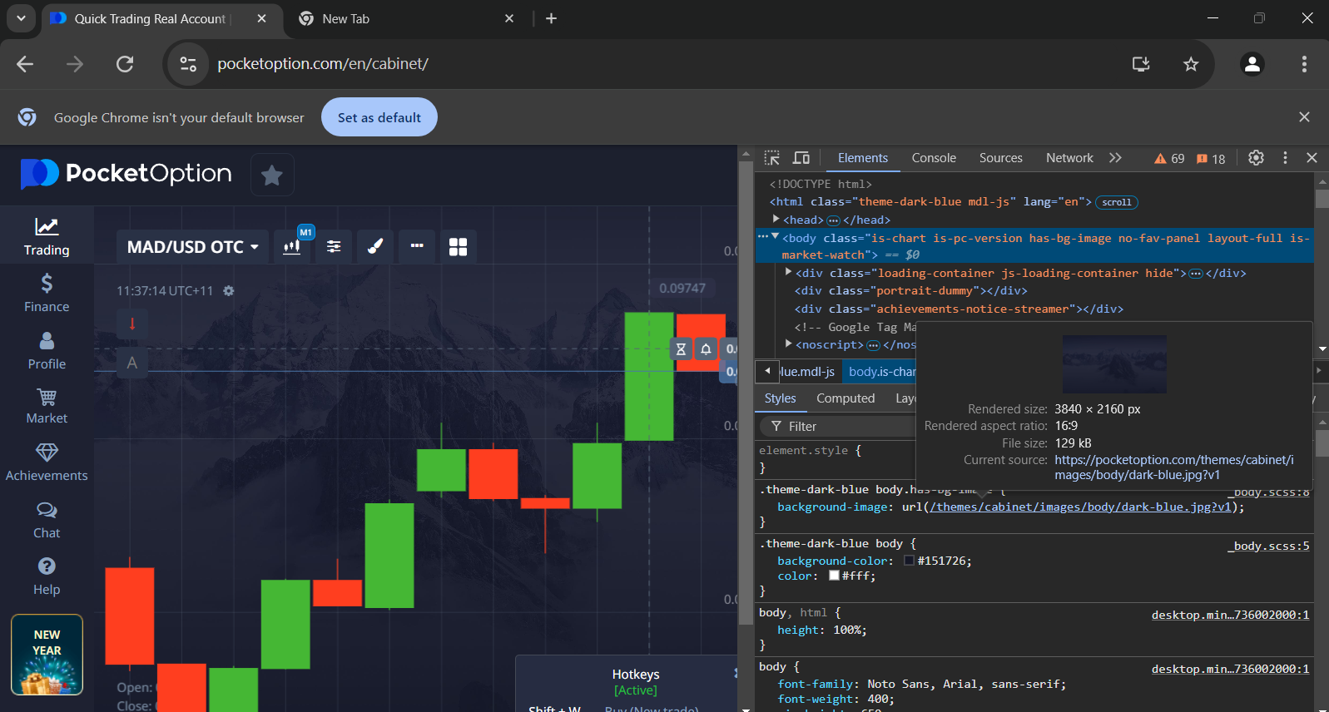
4. Click on Network in the console tab
5. Then Click on the “WS” box in the network tab
6. Once you have clicked the WS box refresh your page
7. You will see a bunch of lines populate
   1. A screenshot of a computer

      Description automatically generated
8. Search for the Socket connection that has and “AUTH” line. Note it should say “session” not “sessionToken”
   1. A screenshot of a computer program

      Description automatically generated
9. Right click the AUTH message and click copy message
   1. A screenshot of a computer

      Description automatically generated
10. You have now successfully retrieved your SSID to paste into the bot
    1. 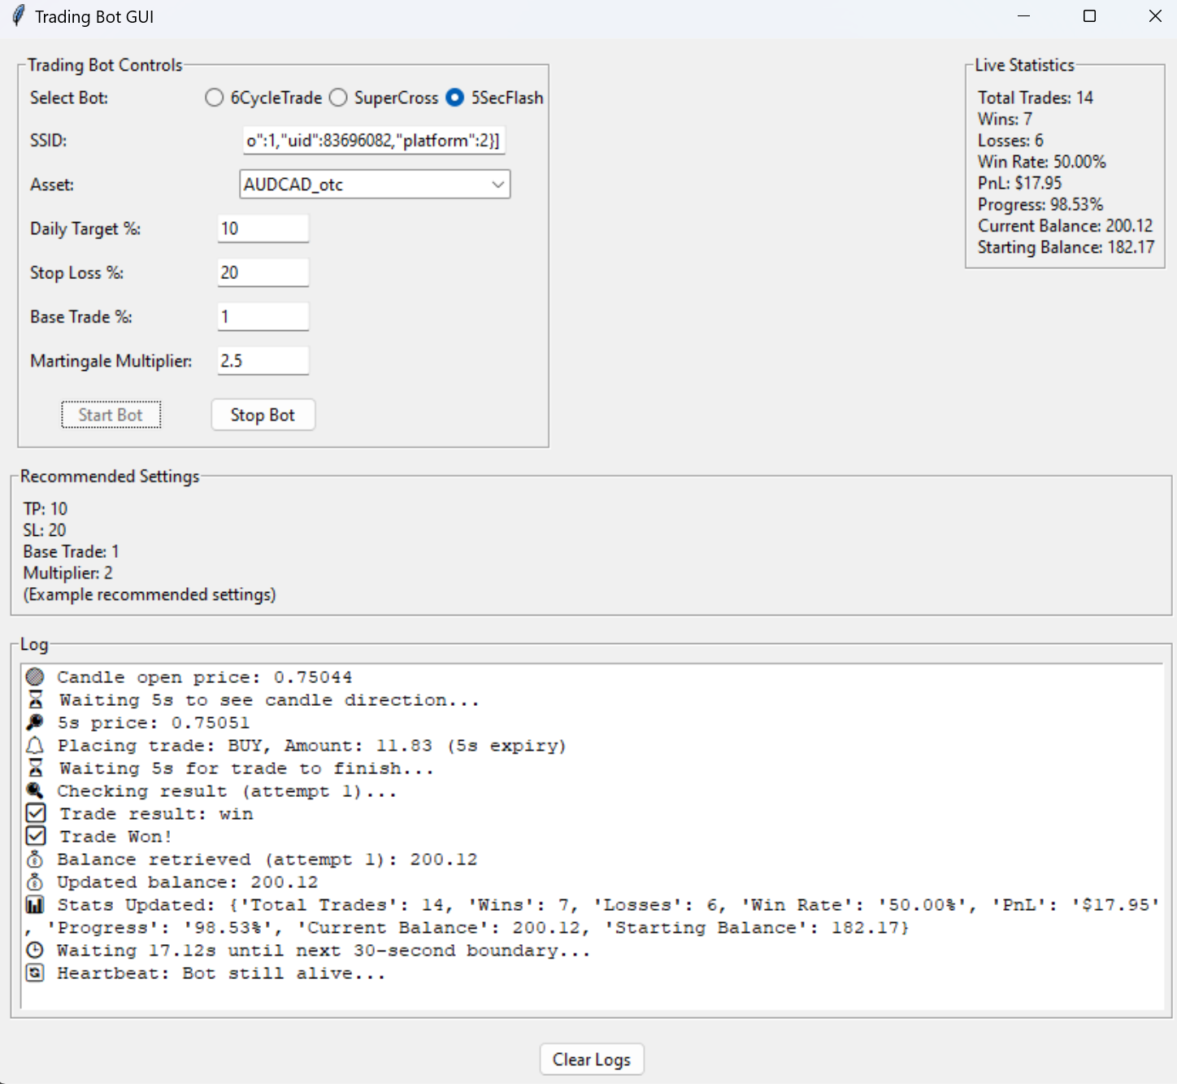
11. You will have to do this process each time you login to a new instance of Pocket option